Introduction to Query Optimization
- Query optimization is a difficult part of the query processing.
- It determines the efficient way to execute a query with different possible query plans.
- It cannot be accessed directly by users once the queries are submitted to the database server or parsed by the parser.
- A query is passed to the query optimizer where optimization occurs.
- Main aim of Query Optimization is to minimize the cost function,
I/O Cost + CPU Cost + Communication Cost
- It defines how an RDBMS can improve the performance of the query by re-ordering the operations.
- It is the process of selecting the most efficient query evaluation plan from among various strategies if the query is complex.
- It computes the same result as per the given expression, but it is a least costly way of generating result.

Importance of Query Optimization
- Query optimization provides faster query processing.
- It requires less cost per query.
- It gives less stress to the database.
- It provides high performance of the system.
- It consumes less memory.
Query Processing
- Query Processing includes translations on high level Queries into low level expressions that can be used at physical level of file system, query optimization and actual execution of query to get the actual result.
- Block Diagram of Query Processing is as:
- 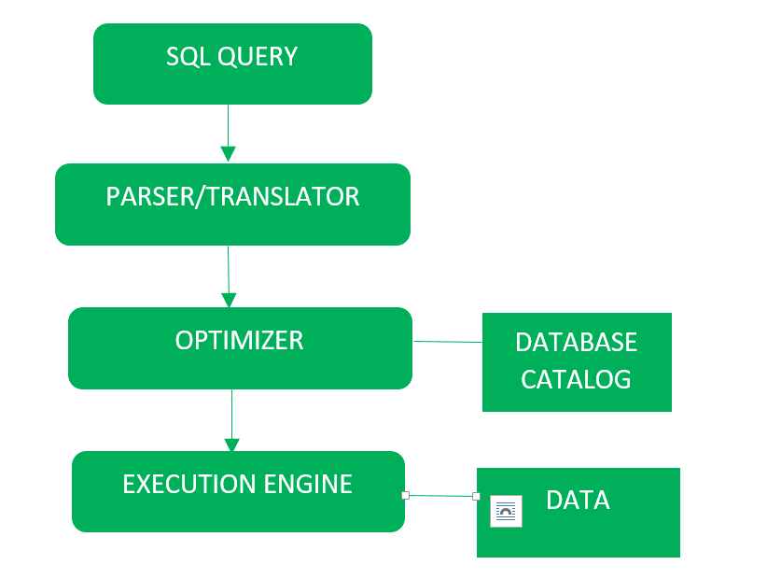
Detailed Diagram is drawn as:
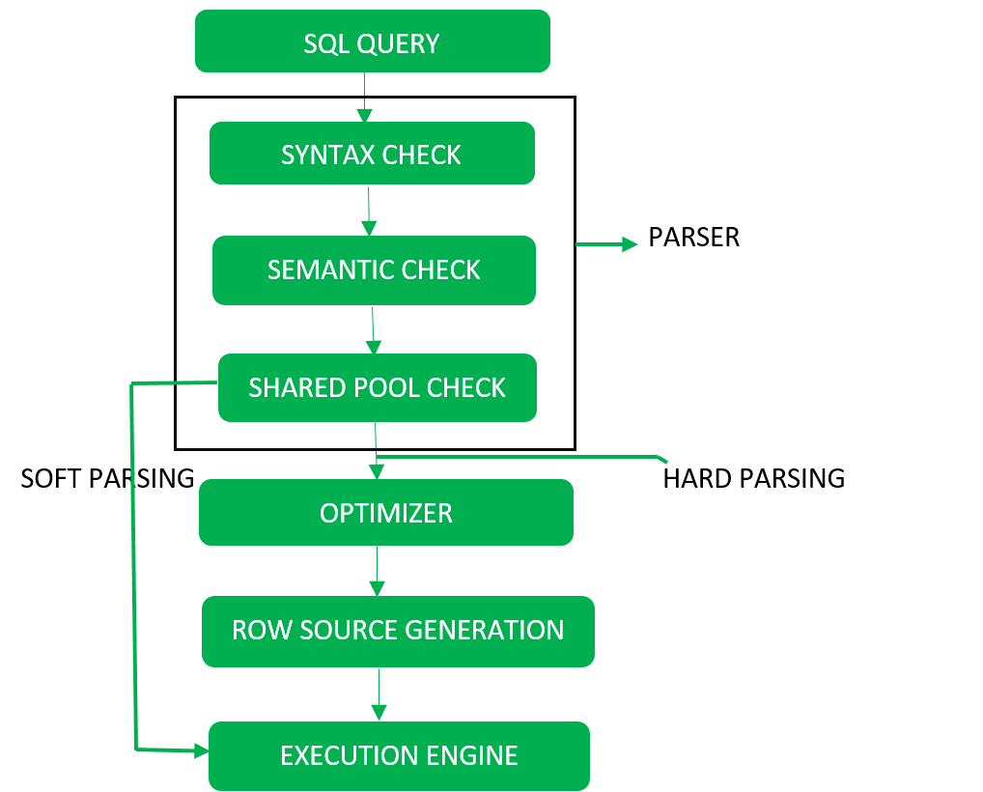
t is done in the following steps:
- Step-1:
Parser: During parse call, the database performs the following checks- Syntax check, Semantic check and Shared pool check, after converting the query into relational algebra.
Parser performs the following checks as (refer detailed diagram):
  - Syntax check – concludes SQL syntactic validity. Example:
SELECT * FORM employee
Here error of wrong spelling of FROM is given by this check.
  - Semantic check – determines whether the statement is meaningful or not. Example: query contains a tablename which does not exist is checked by this check.
  - Shared Pool check – Every query possess a hash code during its execution. So, this check determines existence of written hash code in shared pool if code exists in shared pool then database will not take additional steps for optimization and execution.
- Step-2:
Optimizer: During optimization stage, database must perform a hard parse atleast for one unique DML statement and perform optimization during this parse. This database never optimizes DDL unless it includes a DML component such as subquery that require optimization.
It is a process in which multiple query execution plan for satisfying a query are examined and most efficient query plan is satisfied for execution.
Database catalog stores the execution plans and then optimizer passes the lowest cost plan for execution.
Row Source Generation –
The Row Source Generation is a software that receives a optimal execution plan from the optimizer and produces an iterative execution plan that is usable by the rest of the database. the iterative plan is the binary program that when executes by the sql engine produces the result set.
- Step-3:
Execution Engine: Finally runs the query and display the required result

query evaluation plan
A query evaluation plan (Oracle calls it an “execution plan”) is a program for an abstract machine (interpreter) inside the DBMS. It is produced by the query optimizer.Another name is “access plan” (the DBMS has to decide how to access the rows, e.g. whether to use an index).

In most systems, query evaluation plans (QEPs) are similarto relational algebra expressions (very system dependent).
•
E.g. consider the following SQL query:
SELECT ENAME, DNAME
FROM EMP, DEPT
WHERE EMP.DEPTNO = DEPT.DEPTNO AND JOB = ’MANAGER’
In relational algebra, the example query would be written as:

Complex relational algebra expressions are best displayed as
“operator trees” (showing the flow of data):

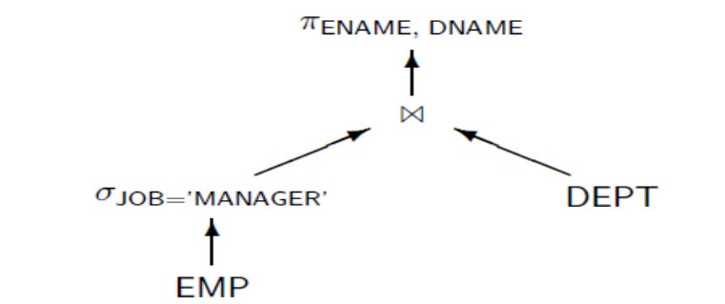

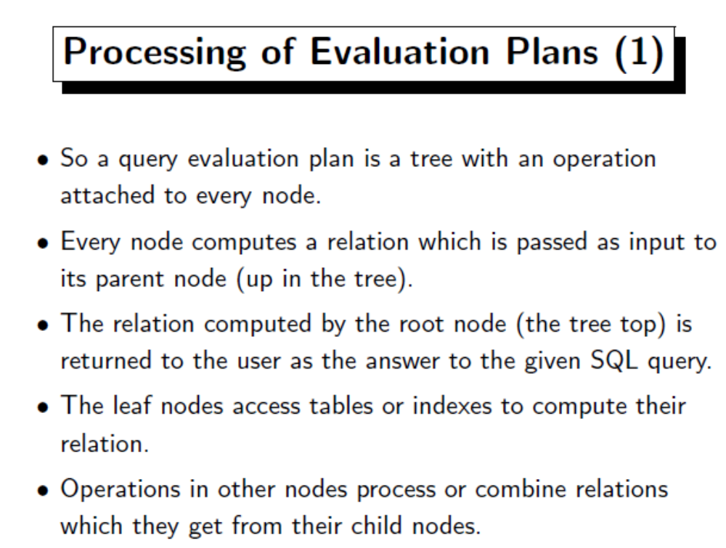

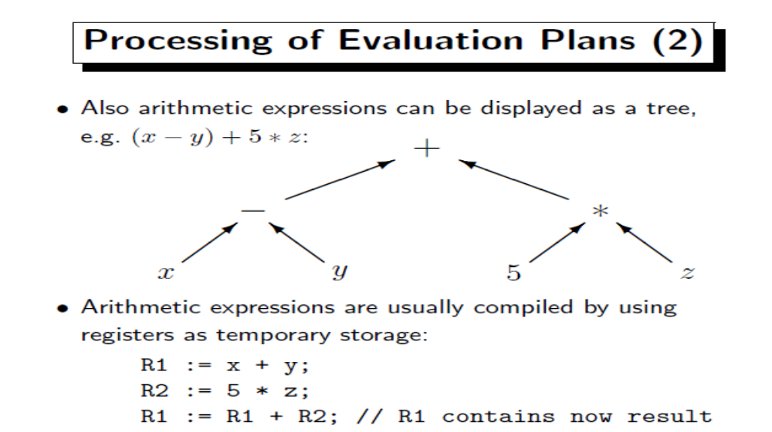

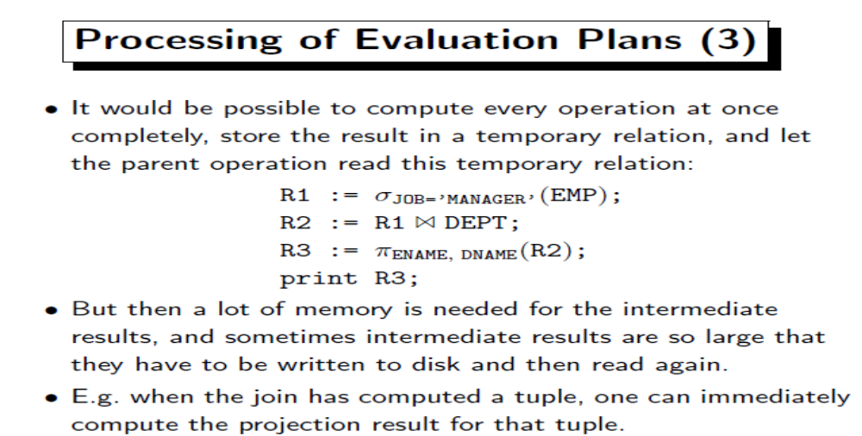

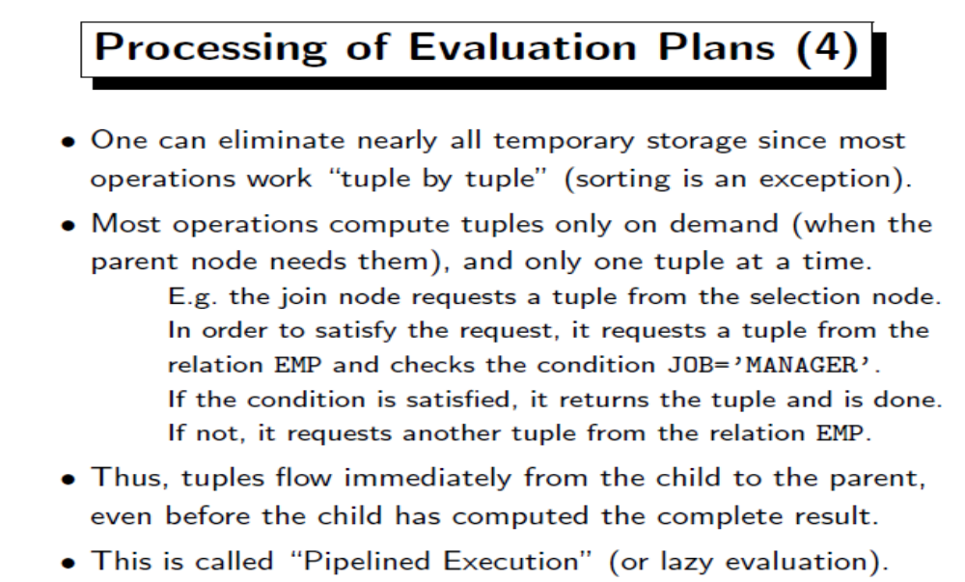


SQL Anywhere supports a variety of different join implementations that the query optimizer chooses from. Each of the join algorithms has specific characteristics that make it more or less suitable for a given query and a given execution environment.
The order of the joins in an access plan may or may not correspond to the ordering of the joins in the original SQL statement; the query optimizer is responsible for choosing the best join strategy for each query based on the lowest execution cost. In some situations, query rewrite optimizations may be utilized for complex statements that either increase, or decrease, the number of joins computed for any particular statement.
There are three classes of join algorithms supported by SQL Anywhere, though each of them has additional variants:
- Nested Loops Join The most straightforward algorithm is Nested Loops Join. For each row on the left-hand side, the right-hand side is scanned for a match based on the join condition. Ordinarily, rows on the right-hand side are accessed through an index to reduce the overall execution cost. This scenario is frequently referred to as an Index Nested Loops Join.
Nested Loops Join has variants that support LEFT OUTER and FULL OUTER joins. A nested loops implementation can also be used for semijoins (most often used for processing EXISTS subqueries).
A Nested Loops Join can be utilized no matter what the characteristics of the join condition, although a join over inequality conditions can be very inefficient to compute.
A Nested Loops FULL OUTER join is very expensive to execute over inputs of any size, and is only chosen by the query optimizer as a last resort when no other join algorithm is possible.
- Merge Join A Merge Join relies on its two inputs being sorted on the join attributes. The join condition must contain at least one equality predicate in order for this method to be chosen by the query optimizer. The basic algorithm is a straightforward merge of the two inputs: when the values of the two join attributes differ, the algorithm scrolls to the next row of the left or right-hand side, depending on which side has the lower of the two values. Backtracking may be necessary when there is more than one match.
There are Merge Join variants to support LEFT OUTER and FULL OUTER joins. Merge Join for FULL OUTER Joins is considerably more efficient than its nested loops counterpart.
The basic Merge Join algorithm is also used to support the SQL set operators EXCEPT and INTERSECT, although these variants are explicitly named as EXCEPT or INTERSECT algorithms within an access plan.
- Hash Join A Hash Join is the most versatile join method supported by the SQL Anywhere database server. The Hash Join algorithm builds an in-memory hash table of the smaller of its two inputs, and then reads the larger input and probes the in-memory hash table to find matches.
Hash Join variants exist to support LEFT OUTER join, FULL OUTER join, semijoin, and anti-semijoin. In addition, SQL Anywhere supports hash join variants for recursive INNER and LEFT OUTER joins when a recursive UNION query expression is being used.
The Hash Inner Join, Left Outer Join, Semijoin, and Antisemijoin algorithms can be executed in parallel.
If the in-memory hash table constructed by the algorithm does not fit into available memory, the Hash Join algorithm splits the input into partitions (possibly recursively for very large inputs) and performs the join on each partition independently. If there is not enough cache memory to hold all the rows that have a particular value of the join attributes, then, if possible, each Hash Join dynamically switches to an index-based nested loops strategy after first discarding the interim results to avoid exhausting the statement's memory consumption quota.
Variants of Hash Join are also utilized to support the SQL query expressions EXCEPT and INTERSECT, although these variants are explicitly named as EXCEPT or INTERSECT algorithms within an access plan.

Cost-Based Optimization
A query optimizer is a part of the relational database software which is meant to analyze a SQL query and then figure out what the best to run that query. That is why it is called a query optimizer, because it’s goal is to optimize the query for the sake of efficiency.
A cost based optimizer will look at all of the possible ways or scenarios in which a query can be executed – and each scenario will be assigned a ‘cost’, which indicates how efficiently that query can be run. Then, the cost based optimizer will pick the scenario that has the least cost and execute the query using that scenario, because that is the most efficient way to run the query.
The cost is an internal numeric measure that represents the estimated resource usage for a plan. The cost is specific to a query in an optimizer environment. To estimate cost, the optimizer considers factors such as the following:
- System resources, which includes estimated I/O, CPU, and memory
- Estimated number of rows returned (cardinality)
- Size of the initial data sets
- Distribution of the data
- Access structures
The execution time is a function of the cost, but cost does not equate directly to time. For example, if the plan for query A has a lower cost than the plan for query B, then the following outcomes are possible:
- A executes faster than B.
- A executes slower than B.
- A executes in the same amount of time as B.
Therefore, you cannot compare the costs of different queries with one another. Also, you cannot compare the costs of semantically equivalent queries that use different optimizer modes.
Example 4-2 Cost in a Sample Execution Plan
The execution plan displays the cost of the entire plan, which is indicated on line 0, and each individual operation. For example, the following plan shows an overall cost of 14.
EXPLAINED SQL STATEMENT:
------------------------
SELECT prod_category, AVG(amount_sold) FROM sales s, products p WHERE
p.prod_id = s.prod_id GROUP BY prod_category

Plan hash value: 4073170114

----------------------------------------------------------------------
| Id | Operation | Name | Cost (%CPU)|
----------------------------------------------------------------------
| 0 | SELECT STATEMENT | | 14 (100)|
| 1 | HASH GROUP BY | | 14 (22)|
| 2 | HASH JOIN | | 13 (16)|
| 3 | VIEW | index$_join$_002 | 7 (15)|
| 4 | HASH JOIN | | |
| 5 | INDEX FAST FULL SCAN| PRODUCTS_PK | 4 (0)|
| 6 | INDEX FAST FULL SCAN| PRODUCTS_PROD_CAT_IX | 4 (0)|
| 7 | PARTITION RANGE ALL | | 5 (0)|
| 8 | TABLE ACCESS FULL | SALES | 5 (0)|
----------------------------------------------------------------------
The access path determines the number of units of work required to get data from a base table. To determine the overall plan cost, the optimizer assigns a cost to each access path:
- Table scan or fast full index scan
During a table scan or fast full index scan, the database reads multiple blocks from disk in a single I/O. The cost of the scan depends on the number of blocks to be scanned and the multiblock read count value.
- Index scan
The cost of an index scan depends on the levels in the B-tree, the number of index leaf blocks to be scanned, and the number of rows to be fetched using the rowid in the index keys. The cost of fetching rows using rowids depends on the index clustering factor.
The join cost represents the combination of the individual access costs of the two row sets being joined, plus the cost of the join operation.

distributed database
A distributed database is a collection of multiple interconnected databases, which are spread physically across various locations that communicate via a computer network.

Features
- Databases in the collection are logically interrelated with each other. Often they represent a single logical database.
- Data is physically stored across multiple sites. Data in each site can be managed by a DBMS independent of the other sites.
- The processors in the sites are connected via a network. They do not have any multiprocessor configuration.
- A distributed database is not a loosely connected file system.
- A distributed database incorporates transaction processing, but it is not synonymous with a transaction processing system.

Distributed Database Management System
A distributed database management system (DDBMS) is a centralized software system that manages a distributed database in a manner as if it were all stored in a single location.

Features
- It is used to create, retrieve, update and delete distributed databases.
- It synchronizes the database periodically and provides access mechanisms by the virtue of which the distribution becomes transparent to the users.
- It ensures that the data modified at any site is universally updated.
- It is used in application areas where large volumes of data are processed and accessed by numerous users simultaneously.
- It is designed for heterogeneous database platforms.
- It maintains confidentiality and data integrity of the databases.

Factors Encouraging DDBMS
The following factors encourage moving over to DDBMS −
- Distributed Nature of Organizational Units − Most organizations in the current times are subdivided into multiple units that are physically distributed over the globe. Each unit requires its own set of local data. Thus, the overall database of the organization becomes distributed.
- Need for Sharing of Data − The multiple organizational units often need to communicate with each other and share their data and resources. This demands common databases or replicated databases that should be used in a synchronized manner.
- Support for Both OLTP and OLAP − Online Transaction Processing (OLTP) and Online Analytical Processing (OLAP) work upon diversified systems which may have common data. Distributed database systems aid both these processing by providing synchronized data.
- Database Recovery − One of the common techniques used in DDBMS is replication of data across different sites. Replication of data automatically helps in data recovery if database in any site is damaged. Users can access data from other sites while the damaged site is being reconstructed. Thus, database failure may become almost inconspicuous to users.
- Support for Multiple Application Software − Most organizations use a variety of application software each with its specific database support. DDBMS provides a uniform functionality for using the same data among different platforms.

Advantages of Distributed Databases
Following are the advantages of distributed databases over centralized databases.
Modular Development − If the system needs to be expanded to new locations or new units, in centralized database systems, the action requires substantial efforts and disruption in the existing functioning. However, in distributed databases, the work simply requires adding new computers and local data to the new site and finally connecting them to the distributed system, with no interruption in current functions.
More Reliable − In case of database failures, the total system of centralized databases comes to a halt. However, in distributed systems, when a component fails, the functioning of the system continues may be at a reduced performance. Hence DDBMS is more reliable.
Better Response − If data is distributed in an efficient manner, then user requests can be met from local data itself, thus providing faster response. On the other hand, in centralized systems, all queries have to pass through the central computer for processing, which increases the response time.
Lower Communication Cost − In distributed database systems, if data is located locally where it is mostly used, then the communication costs for data manipulation can be minimized. This is not feasible in centralized systems.

Physical & Logical Data Structures in DBMS:

The physical data structure refers to the physical arrangement of the data on the secondary storage device, usually disk. Typically, this physical structure is the concern of specialists who design DBMSs. Analysts, programmers, and users are generally less concerned with the physical structure than with the logical structure.
- Physical Structure: it is simply the physical data files that you can see in a file manager. You can find most of them in the directory where your database is resided. Few types of file:
- Data File: extension is DBF, where the data is stored. It is a physical file on disk that is created by the Database and contains data structures such as tables and indexes. Data is written to these files in a proprietary format that cannot be read by other programs.

Several mechanisms are available for allocating and managing the storage of these files. The most common mechanisms include:

Automatic Storage Management (ASM).

Operating system file system:Most of the databases store files in a file system, which is a data structure built inside a contiguous disk address space. All operating systems have file managers that allocate and de-allocate disk space into files within a file system.

A file system is commonly built on top of a logical volume constructed by a software package called a logical volume manager (LVM). The LVM enables the pieces of multiple physical disks to be combined into a single contiguous address space that appears as one disk to higher layers of software.

Raw device:Raw devices are disk partitions or logical volumes not formatted with a file system. The primary benefit of raw devices is the ability to perform direct I/O and to write larger buffers. In direct I/O, applications write to and read from the storage device directly, bypassing the operating system buffer cache.

Cluster File System: is a software that enables multiple computers to share file storage while maintaining consistent space allocation and the file content. With a cluster file system, the failure of a computer in the cluster does not make the file system unavailable. In an operating system file system, however, if a computer sharing files through NFS or other means fails, then the file system is unavailable.

- Control File: extension is CTL, where the database current state is stored. It is a small binary file that records the physical structure of the database. The control file includes:
- The database name
- Names and locations of associated datafiles and redo log files
- The timestamp of the database creation
- The current log sequence number
- Checkpoint information

The control file must be available for writing by the Database server whenever the database is open. Without the control file, the database cannot be mounted and recovery is difficult.

- Parameter File:A parameter file is a file that contains a list of initialization parameters and a value for each parameter. You specify initialization parameters in a parameter file that reflect your particular installation.
- A server parameter file is a binary file that acts as a repository for initialization parameters. The server parameter file can reside on the machine where the database server executes.
- An initialization parameter file is a text file that contains a list of initialization parameters. The file should be written in the client's default character set. Sample entries in an initialization parameter file are:
PROCESSES = 100
OPEN_LINKS = 12
GLOBAL_NAMES = true

- Redo Log: extension is RDO, It consists of two or more pre-allocated files that store all changes made to the database as they occur. Every instance of anDatabase has an associated redo log to protect the database in case of an instance failure.

- Redo log files are filled with redo records. A redo record, also called a redo entry, is made up of a group of change vectors
- Redo entries record data that you can use to reconstruct all changes made to the database, including the undo segments.
- Redo records are buffered in a circular fashion in the redo log buffer of the SGAand are written to one of the redo log files by the Log Writer (LGWR) database background process.
- Redo records can also be written to a redo log file before the corresponding transaction is committed.

The redo log of a database consists of two or more redo log files. The database requires a minimum of two files to guarantee that one is always available for writing while the other is being archived (if the database is in ARCHIVELOG mode).

LGWR writes to redo log files in a circular fashion. When the current redo log file fills, LGWR begins writing to the next available redo log file. When the last available redo log file is filled, LGWR returns to the first redo log file and writes to it, starting the cycle again.

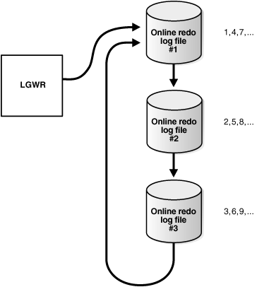
Fig. Use of Redo Log Files by LGWR

Logical Structure: it only stay in memory, where physically store in physical file. It only appear when the database service is started, and only can be view by using certain database tools. Few types of logical structure:
Tablespace: where the tables or data are stored. 1 tablespace can map to 1 or more data files.
0..Segment: Smaller unit in tablespace, which can further categorized into data segment, index segment, temporary segment and rollback segment.
- Extend: Smaller unit in Segment.
- Block: Smaller unit in Extend.

